**###################Password Recovery######################**

**##Recover the root password as "redhat@156" on a given virtual server.**

**Step1:**

**#Reboot the system and at the start prompt of linux select kernel and press e**

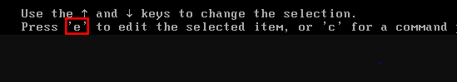

**Step2:**

**#Go to linux 16 line, press end key there it will reach at UTF-8 please type there.**



**rd.break**

**Step3:**

**#Press “Ctrl+x” to boot with these options. This will boot to the initramfs prompt with a root shell.**

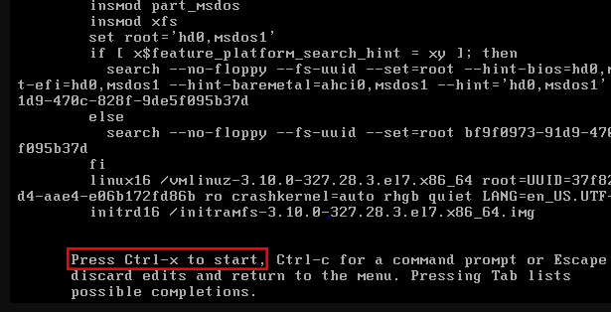

**--> ctlr+x**

**Step4:**

**#At this stage, the root file system is mounted in read only mode to /sysroot and must be remounted with read/write (rw) permissions in order for us to actually make any changes. This is done with the ‘mount -o remount,rw /sysroot’ command.**

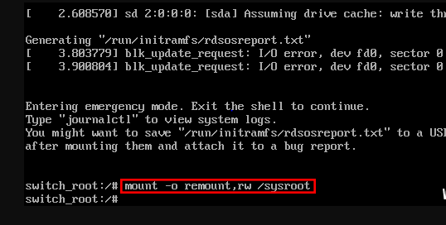**#mount -o remount,rw /sysroot**

**Step5:**

**#Once the file system has been remounted, change into a chroot jail so that /sysroot is used as the root of the file system. This is required so that any further commands we run will be in regards to /sysroot. This is done by running ‘chroot /sysroot’.**

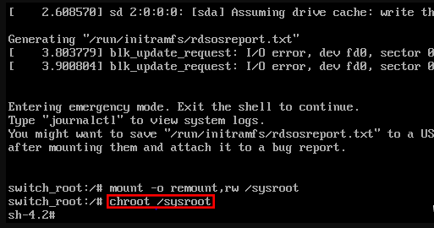

**#chroot /sysroot**

**Step6:**

**#From here the root password can be reset with the ‘passwd’ command**

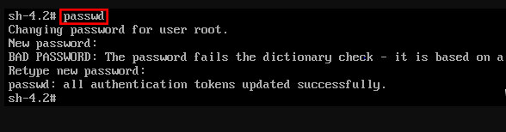

**#passwd root**

**-->New Password:**

**-->Retype new passwd:**

**Step7:**

**#If you’re not using SELinux, you could reboot at this point and everything would be fine, however by default CentOS/RHEL 7 use SELinux in enforcing mode, so we need to fix the context of the /etc/shadow file. This is because when the ‘passwd’ command is run, it creates a new /etc/shadow file. As SELinux is not running in this mode the file is created with no SELinux contexts, which can cause problems when we reboot. Create the /.autorelabel command using ‘touch’.**

**#touch /.autorelabel**

**Step8:**

**#Enter the ‘exit’ command twice, the first one will exit the chroot jail environment while the second will exit the initramfs root shell and reboot the system.**



**#exit**

**#exit (2 time exit is required)**

**Once the reboot has completed you will be able to use the root account with your newly set password.**